|  |  |  |
| --- | --- | --- |
| Web Development 1000 | 2021-JULY | Assignment 5 |

**Task:** Create a new and unique web page utilizing the elements and attributes we have learned and practiced so far in class.

**Learning outcome evaluated:**

2 Based on web standards, author web pages using HTML/CSS with a text editor.

2.1 Create an HTML document without a WYSIWYG HTML editor.

2.2 Insert and use HTML tags, graphics, and special characters.

2.3 Create a variety of hyperlink types.

2.4 Use absolute and relative path names.

2.6 Distinguish different image file formats and select appropriate formats for sites.

**Instructions:**

Individually, with your professor acting as the client and you as the developer do the following;

1. The client is to envision a website that they want created, using the items that we have learned to date. ok
2. Use the planning and design concepts covered on Day 1, the developer is to plan a web page. Describe the company/client your client has described and envision the page.
3. Using flowcharts and storyboard plan your site. Get client sign-off.
   1. You will be marked on the completeness and professionalism of your final documents! They should be done in Word and properly commented. If in doubt, look at the content in week 1 called Website Storyboard
4. Ensure that you fully comment your code, including:
   1. Your name
   2. That this page is your week 1 project
   3. The current date
   4. What elements you are including in your page
   5. YOU MUST comment why you used a specific tag the first time you use it citing one of the C.R.A.P. design principles.
5. Go back and review the requirements for each of the assignments you have completed this week. Be sure to include content (tags and attributes) and concepts from:
   1. Assignment 1
      1. Good design principles
      2. Storyboard your page
   2. Assignment 2
      1. Your name in the title
      2. Good tagging habits in keeping with industry best practices
      3. Good basic HTML document layout, include your language indication in your HTML tag
   3. Assignment 3
      1. A good cross section of tags that were learned about in this assignment, be sure they are used properly and not just for the sake of including them.
   4. Assignment 4
      1. Apply a variety of inline/internal styles to your page to make it attractive and in keeping with good design principles
      2. Include an absolute link and a relative link in your page
6. Every page of you site must have your personal logo on it. The size of the logo MUST be 200px X 200px DONE
7. 5 marks will be awarded based on adherence to C.R.A.P. principles across all pages of the site.
8. Validate your web page using the W3C Markup Language Validator and take a screen capture showing your validation results. Be sure to make necessary corrections.
9. Review the site with your “client” and get them to “sign off” on it.

And be sure to comment your code thoroughly!

Take a screenshot of your all your Webpages for this project and put it here (Screen Shots as needed) webpages 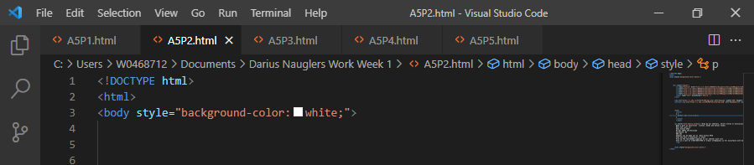 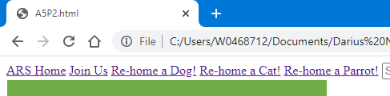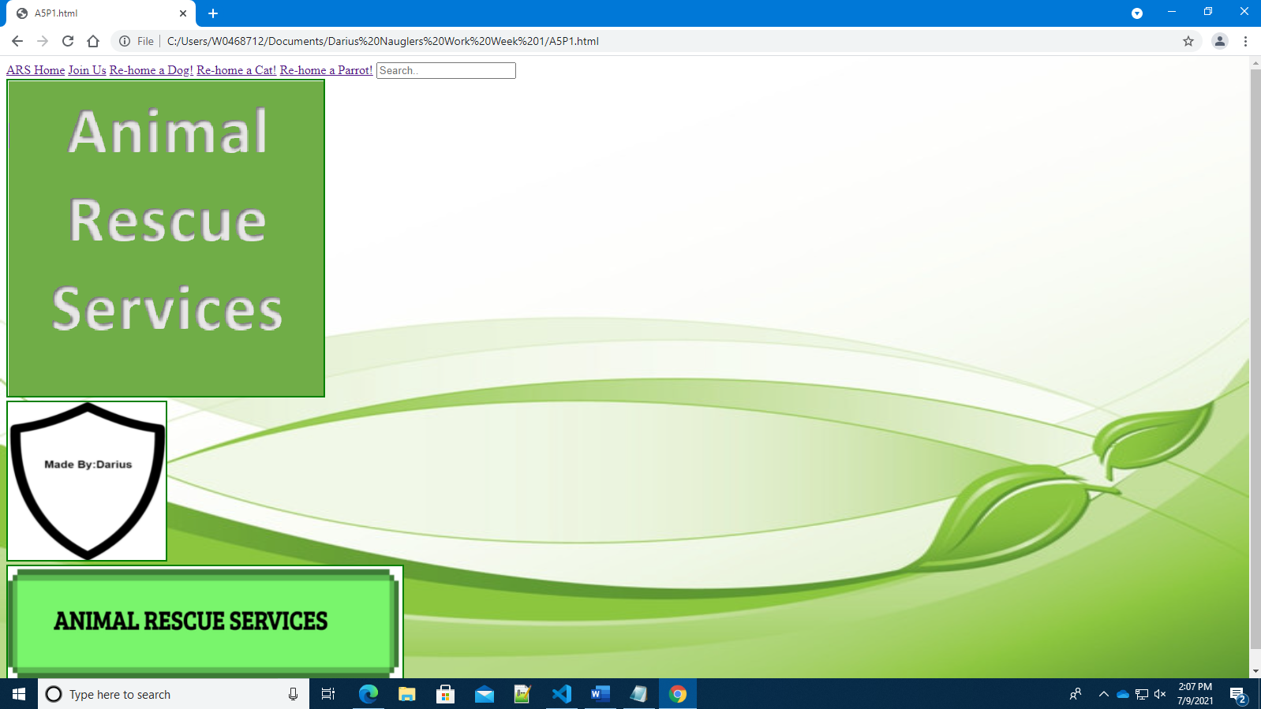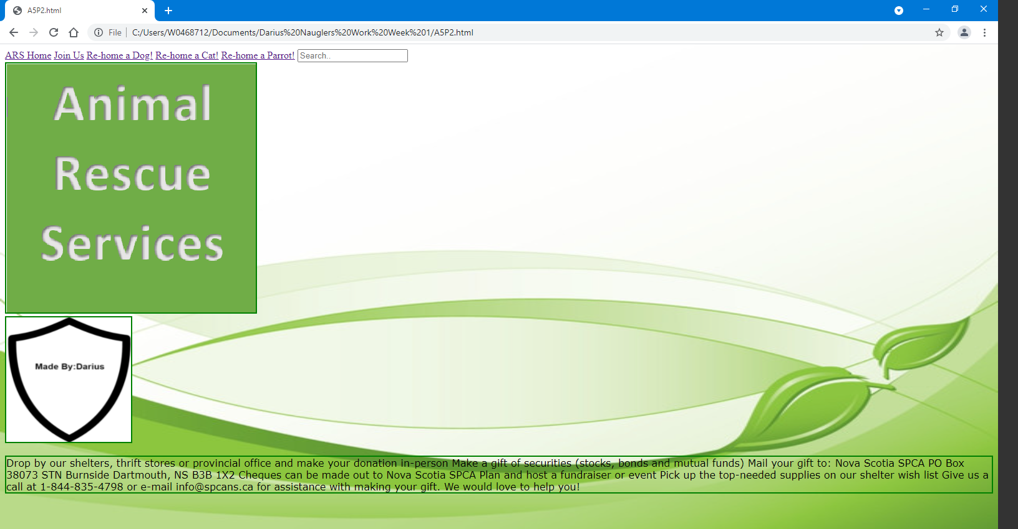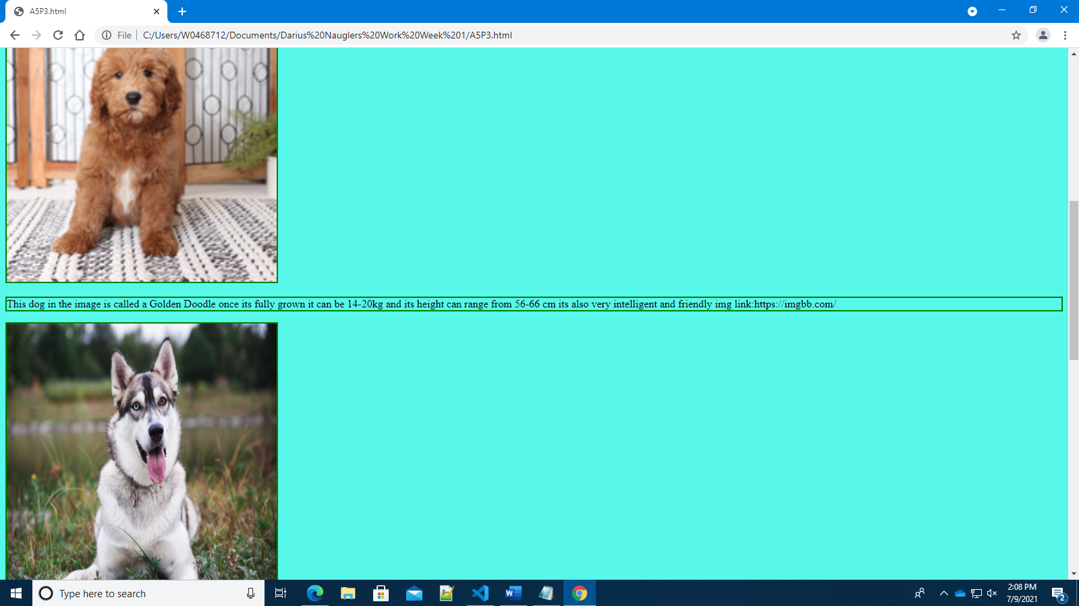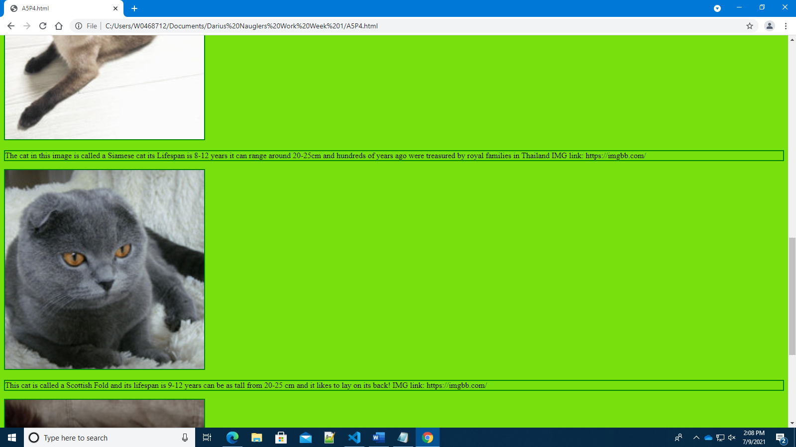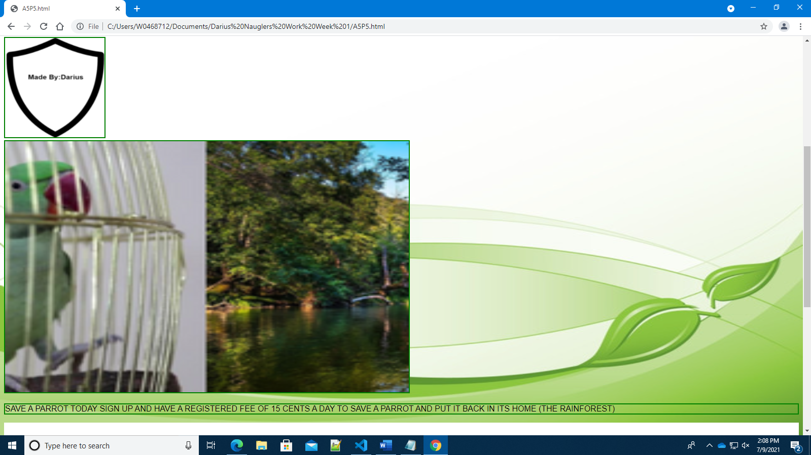

Place your CODE here (Code Submission) Handed In on separate Notepad

Paste flow chart picture here: 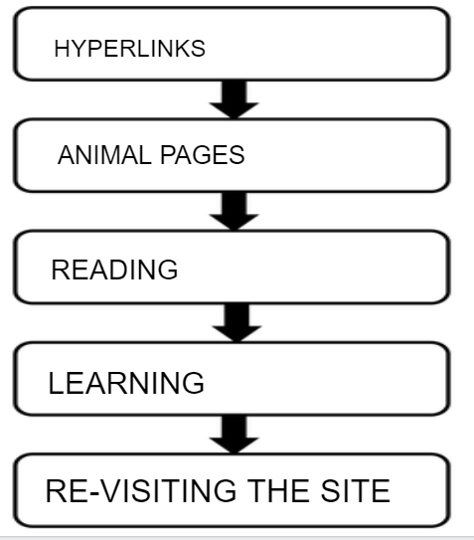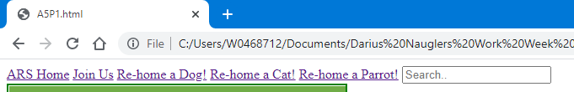

Paste storyboard picture here: 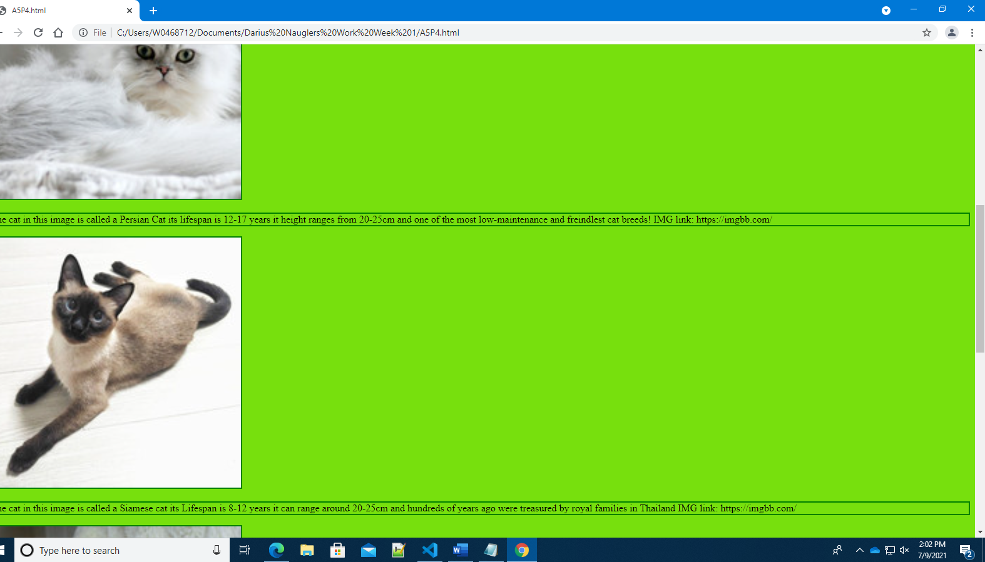

**Peer Discussion:** You are welcome to discuss and plan your website in small groups of 2-3 students but everyone must storyboard and code their INDIVIDUAL pages. You are also welcome to show your work to other students and get/give constructive feedback, as long as each student completes their own project themselves.

Be ready to talk about the components you have included!

**Notes:it was way easier coding when you follow tutorials instead of copy and pasting,except for I only need to know one thing that’s how to position an image properly**

Make sure the screen captures are clearly visible and show what was asked for in the assignment.

When you capture a web page the URL must be clearly visible!

The site. ARS, Animal Rescue Services is a volunteer organization that rescues and re-homes all manner of animals. ARS has come to you and asked you to create a website for them. They want this site to be fun! (no sad pictures!) The site is to have the following on EACH PAGE.

ALS Logo (attached) 400px X 400px near the top of the page (ARSLogo.png is provided). Developers Logo (your Logo), 200px X 200px near the bottom of the page.

Pictures that are saved on the local computer and pointed to via relative references.

Pictures that are on the web and pointed to with absolute references.

Pictures are to have GREEN Boarders.

All pictures must have citations.

There must be a page called “ARS Home” saved as index.html, every page must have a link back to this page. There must be a link to every other page from here. There should be a BIG BOLD Title “Animal Rescue Services” on the home page.

A page called “Join us” Asking to join or contribute to ARS Background color of your choice in HEX This page must have the following text, formatted in a nice easy to read form.

Drop by our shelters, thrift stores or provincial office and make your donation in-person

Make a gift of securities (stocks, bonds and mutual funds)

Mail your gift to:

Nova Scotia SPCA

PO Box 38073 STN Burnside

Dartmouth, NS

B3B 1X2

Cheques can be made out to Nova Scotia SPCA

Plan and host a fundraiser or event

Pick up the top-needed supplies on our shelter wish list

Give us a call at 1-844-835-4798 or e-mail info@spcans.ca for assistance with making your gift. We would love to help you!

A page called Re-Home a Dog with lots of dog pictures and dog information. This page must also link to another site that talks about caring for dogs. The background color for this page should be #57f7ea

A page called Re-Home a Cat with lots of cat pictures and cat information. This page must also link to another site that talks about caring for cats. Background color #77e00d

A page called Something Different with pictures of animals OTHER than dogs or cats. This page must contain a link to the Nova Scotia SPCA. ( <https://www.novascotiaspca.ca/>) Background color of your choice in HEX